PROJECT PROGRESS REPORT

PROJECT DETAILS

PROJECT NAME
VOLODS
GITHUB LINK | DATE | STATUS
https://github.com/OliveERP/WebMekanics.git 16-12-2022 ONGOING

OVERALL PROGRESS
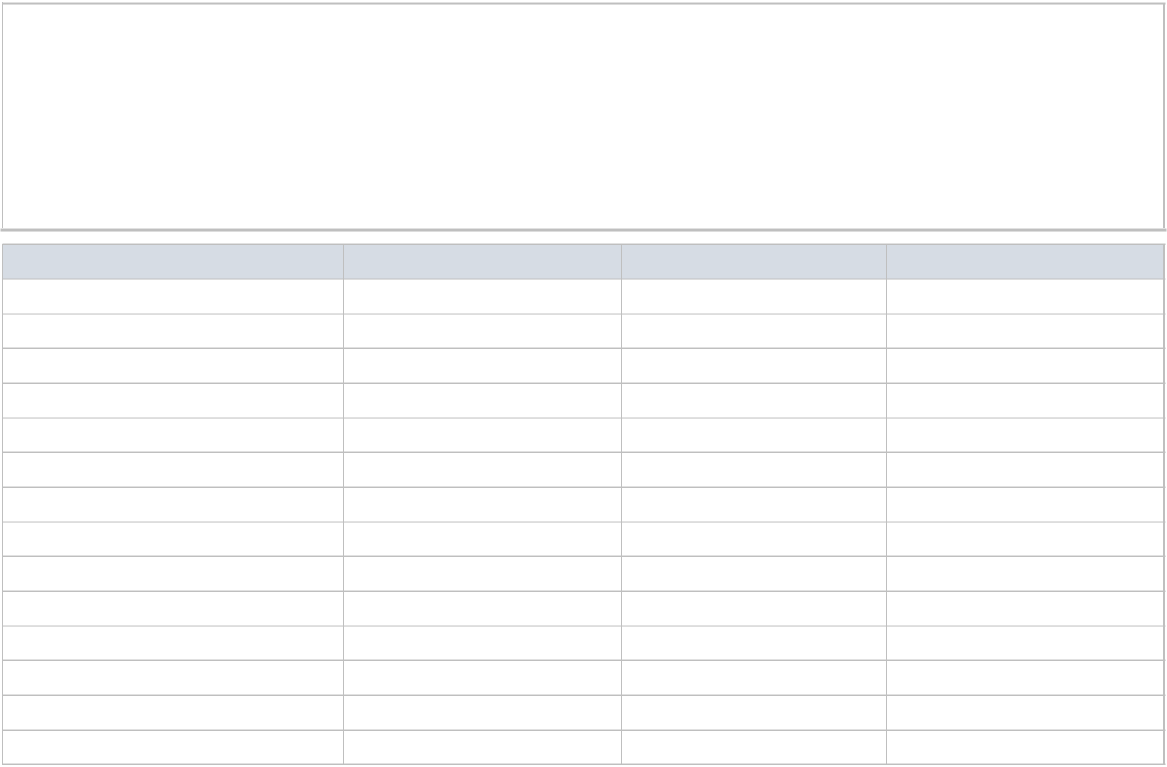

Custom App is created (Volods). All necessary changes are made in the custom app and is made available on GitHub.

Other changes like, to disable automatic rounding adjustments and pdf conversion feature, to set a default filter, etc requires customization in user’s instance.

A short video was shared earlier to demonstrate first FOUR output on the system.

TASK/REQUIREMENT STATUS OUTPUT COMMENTS/DETAILS

Item picture in List View Completed Item Picture displays in list views

Supplier Part No in Item Search Completed Item is searchable on its Supplier part no mentioned in Item
Item Picture in item search Completed Item Picture is displayed as thumbnail in drop down

Price of item previously sold to exact- Completed Last Sold Price overrides the default Item Price list according
-customer the customer selected

Sales Return against multiple invoices Completed Multiple invoice selection option is created

Payment Receipt from multiple invoices Existing Feature of ERPNext

Update Breadcrumbs Checked and Verified for Selling > Sales Order

ONGOING TASKS
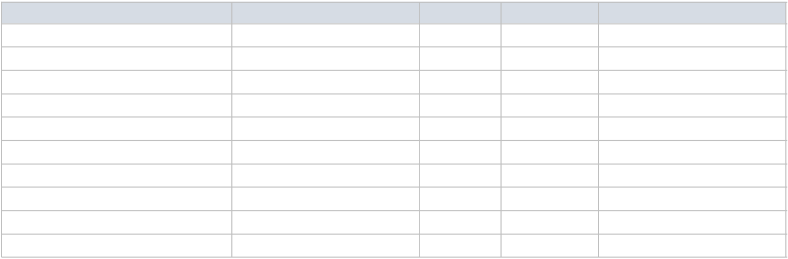

TASK DESCRIPTION OF TASK COMPLETION PERCENTAGE

Two-way ERPNext-Quickbooks integration 65%
Pick list needs item location info
DESCRIBE ANY DELAYS AND / OR INCIDENTS


ADDITIONAL REMARKS
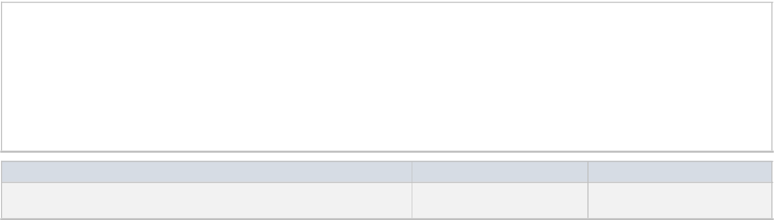

PREPARER NAME AND TITLE PREPARER SIGNATURE DATE
DISCLAIMER

